MICHIGAN SEVERE WEATHER
AWARENESS WEEK
APRIL 8-14, 2018
YOUR TOOLKIT

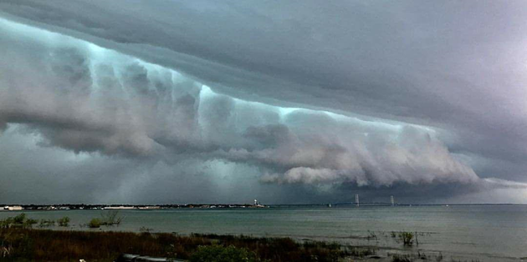
June 11, 2017 severe weather approaching the Mackinac Bridge. Picture taken by Paola Catallo-Lieghio

This packet was prepared by the Michigan Committee for Severe Weather Awareness (MCSWA), a coalition formed in 1991 to promote safety awareness and coordinate public information efforts regarding tornadoes, flooding, lightning and winter weather.
1

2

SEVERE WEATHER AWARENESS PACKET

TABLE OF CONTENTS

Michigan Committee for Severe Weather Awareness Contacts 3
Michigan Statewide Tornado Drill 4
2017 Severe Weather Review 5
Michigan Tornado History by County 8
Tornado and Thunderstorm Safety 9
Tornado and Thunderstorm Facts 10
Flood Preparation and Planning 12
Flood Insurance 14
Lightning Safety 16
Disaster Preparedness for Pets 17
Weather Warning Systems 18
National Weather Service Contacts 19

MICHIGAN COMMITTEE FOR
SEVERE WEATHER AWARENESS

Richard Pollman
National Weather Service 9200 White Lake Road White Lake, MI 48386-1126 248-625-3309, Ext. 726
richard.pollman@noaa.gov

Lori Conarton, Secretary Insurance Alliance of Michigan 334 Townsend
Lansing, MI 48933
517-371-2880

iam@insurancealliancemichigan.org

James Maczko
Warning Coordination Meteorologist Weather Forecast Office - Grand Rapids 4899 South Complex Dr., S.E.
Grand Rapids, MI 49512 616-949-0643 ext. 726
james.maczko@noaa.gov

Paul Gross Meteorologist, WDIV-TV 550 W. Lafayette
Detroit, MI 48226-3140
313-222-0444, Ext. 318
paulg@wdiv.com

Kevin Thomason
State Farm Insurance
P.O. Box 4094
Kalamazoo, MI 49003-4094
269-384-2580

kevin.thomason.a18z@Statefarm.com

Byron Lane, P.E., Supervisor
Hydrologic Studies and Dam Safety Unit
Water Resources Division
Michigan Department of Environmental Quality
517-281-6821
mailto:laneb@michigan.gov

Richard A Foltman, CCM Specialist-Meteorologist DTE Energy
One Energy Plaza, 379SB Detroit, MI 48226-1221
313-235-6185
foltmanra@dteenergy.com

David Chapman
MI Earth Science Teachers Association Okemos High School
2800 Jolly Road
Okemos, MI 48864
517-706-4886
dave.chapman@okemosschools.net

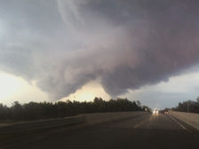
Tornado in Grayling area.

Statewide Tornado Drill

During Severe Weather Awareness Week, April 8-14, emergency management partners statewide are encouraging Michiganders to conduct a statewide tornado drill at 1:00 p.m. ET on Wednesday, April 11.

All businesses, organizations, families and individuals are welcome to participate in the voluntary statewide preparedness activity. Nearly all state of Michigan facilities will be participating.

While tornadoes can occur any time of the year, they are especially common during the late spring and early summer months. As one of nature’s most violent storms, they can devastate homes and property in just seconds. Average lead time for tornadoes is 10 to 15 minutes, which is why Michigan citizens are encouraged to prepare and plan before a tornado strikes.

Here are some tips to prepare your family for a tornado:

•Create an emergency preparedness kit for your home.
•Develop and implement a family communications plan with family members living in your home.
•Listen to your NOAA Weather Radio, commercial radio or television newscasts for the latest information.
•Be aware of the danger signs indicating a tornado.

FOR MORE INFORMATION VISIT

WWW.MCSWA.COM
WWW.NWS.NOAA.GOV/OM/TORNADO
WWW.MICHIGAN.GOV/MIREADY

2017 SEVERE WEATHER REVIEW

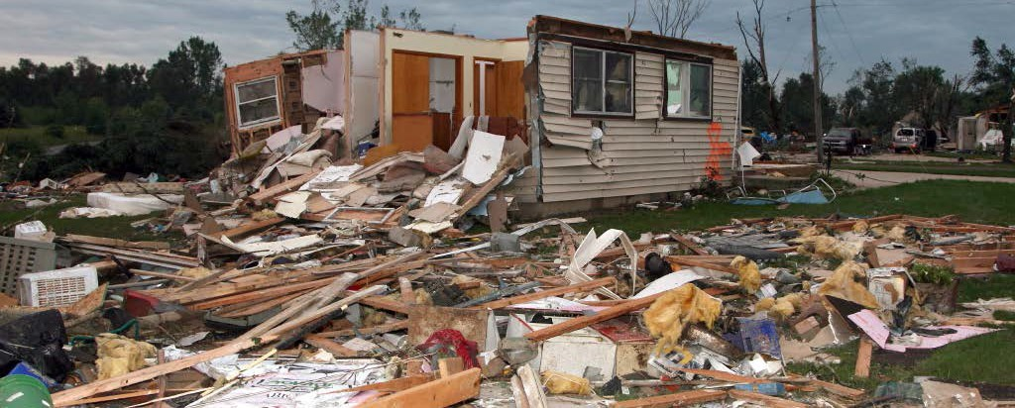

Michigan’s severe weather season in 2017 will be noted by how far below average the total number of events were during the year. However, the year did remind all Michigan citizens just how costly even a below average severe weather season can be. There were 5 directly weather-related fatalities in 2017 and a flood event which hit central Lower Michigan that caused over $220 million in damages.

Of the 5 weather related fatalities, 3 were caused by high winds and the other 2 were a result of flooding. On March 8, 2017, a very strong area of low pressure moved just north of the Great Lakes region dragging a cold front through the state. The weather system created wind gusts that exceeded 60 mph for up to 6 to 8 hours for many locations across Lower Michigan. Over 1 million homes and businesses lost power. Unfortunately, 2 people died when a tree crashed on top of their car while they were driving along M-115 in Clare County.

During the late evening hours of July 6 and into the early morning hours of July 7, 2017, severe thunderstorms developed over Illinois, Wisconsin and Lake Michigan and plowed into southwest Lower Michigan. Numerous tree and power lines fell in a 100-mile long and 30-mile wide swath from Grand Haven to near Jackson. An unverified gust of at least 88 mph and possibly as high as 100 mph was recorded on a home weather station in the South Highland area. Another wind gust of 88 mph was recorded on a rooftop at Grand Valley State University. A man was killed when a large tree fell through his house in Grand Haven when a measured 91 mph wind gust roared through the city.

A powerful storm system moved through the northern Great Lakes on October 24 and produced strong northerly winds with gusts up to 60 mph. These intense winds pushed the waters of Lake Superior onto the lakeshore areas in Marquette and Alger Counties in the Upper Peninsula. In addition to nearly $1 million in damages, two people lost their lives in the flood.

Considerable damage was caused by a June flood across central Lower Michigan. Warm and moist tropical air pushed northward across Lower Michigan on June 22 sparking scattered severe thunderstorms along and south of I-96. These storms continued through the evening prior the severe threat switched over to a flooding threat during the early morning hours of June 23. Thunderstorms repeatedly moved over Mt. Pleasant to Midland to Bay City. Overnight rainfall totals were excess of 6 inches for much of the region leading to major flooding. Over 60 homes were destroyed while another 2000 were damaged. Over 300 roads and bridges were damaged or destroyed. Thankfully no lives were lost but damages exceeded $220 million.

Other storms of note included an incredibly early Tornado Outbreak in far southwest Lower Michigan on the last day in February! Record breaking warmth streamed into much of Michigan during the last two weeks of February 2017.
Low pressure deepened northeast into the Great Lakes region late February 28 into early March 1 and help push a cold front through the state that ended the record warmth. Severe thunderstorms developed along the front for areas along and north of the toll road in Indiana and Lower Michigan during the early evening. The storms produced pockets of large hail and damaging winds. There were also 4 EF1 tornadoes across Berrien, Cass and St. Joseph Counties in Michigan. The tornadoes were each on the ground for 1 to 4 miles with a path width around 100 yards. Most of the damage was to trees, mobile homes and RVs, barns and other outbuildings, although there was some minor roof and siding damage to other homes and one church. This event was noteworthy for how early the tornadoes hit Michigan.
The only other recorded February tornado was on February 28, 1974 in Wayne County. The rare February severe weather wasn’t limited to just the tornadoes. There were many reports of wind and hail damage across Lower Michigan. Numerous large hail reports were observed across northern Michigan, the largest being 1.50 inches in Missaukee and Oscoda Counties. The hail was so deep in some areas that the road commission had to put on plows to clear some roads. These were the first February severe thunderstorm warnings ever issued from the NWS Gaylord office.

The following is a list of tornadoes experienced by each county in Michigan.

County | 1950-2017 | 2017 | County | 1950-2017 | 2017
Alcona | 11 | 0 | Lake | 2 | 0
Alger | 6 | 0 | Lapeer | 21 | 0
Allegan | 34 | 1 | Leelanau | 4 | 0
Alpena | 14 | 0 | Lenawee | 32 | 0
Antrim | 10 | 1 | Livingston | 26 | 0
Arenac | 7 | 0 | Luce | 4 | 0
Baraga | 2 | 0 | Mackinac | 6 | 0
Barry | 18 | 0 | Macomb | 21 | 0
Bay | 14 | 0 | Manistee | 2 | 0
Benzie | 4 | 0 | Marquette | 11 | 0
Berrien | 32 | 1 | Mason | 5 | 0
Branch | 17 | 0 | Mecosta | 9 | 0
Calhoun | 16 | 0 | Menominee | 9 | 0
Cass | 18 | 2 | Midland | 10 | 0
Charlevoix | 4 | 0 | Missaukee | 8 | 0
Cheboygan | 7 | 0 | Monroe | 34 | 0
Chippewa | 6 | 0 | Montcalm | 12 | 0
Clare | 8 | 0 | Montmorency | 6 | 0
Clinton | 19 | 0 | Muskegon | 8 | 0
Crawford | 12 | 0 | Newaygo | 13 | 0
Delta | 11 | 0 | Oakland | 32 | 0
Dickinson | 9 | 0 | Oceana | 5 | 0
Eaton | 25 | 0 | Ogemaw | 16 | 1
Emmet | 5 | 0 | Ontonagon | 3 | 0
Genesee | 45 | 0 | Osceola | 16 | 0
Gladwin | 9 | 0 | Oscoda | 5 | 0
Gogebic | 5 | 0 | Otsego | 5 | 0
Grand Traverse | 4 | 0 | Ottawa | 20 | 0
Gratiot | 15 | 0 | Presque Isle | 6 | 0
Hillsdale | 24 | 0 | Roscommon | 8 | 0
Houghton | 1 | 0 | Saginaw | 25 | 0
Huron | 15 | 0 | Sanilac | 17 | 0
Ingham | 28 | 0 | Schoolcraft | 3 | 0
Ionia | 22 | 1 | Shiawassee | 29 | 0
Iosco | 13 | 0 | St. Clair | 23 | 0
Iron | 7 | 0 | St. Joseph | 12 | 1
Isabella | 13 | 0 | Tuscola | 20 | 1
Jackson | 17 | 0 | Van Buren | 20 | 0
Kalamazoo | 25 | 0 | Washtenaw | 28 | 0
Kalkaska | 8 | 0 | Wayne | 30 | 0
Kent | 36 | 1 | Wexford | 8 | 0
Keweenaw | 2 | 0

A single tornado can cross county lines. Therefore, the sum of the counties will not equal the total number of tornadoes statewide.

TORNADO AND THUNDERSTORM SAFETY

Preparing for a tornado or thunderstorm:
  - Plan. Be sure everyone in your household knows where to go and what to do in case of a tornado or thunderstorm warning.
  - Know the safest location for shelter in your home, workplace and school. Load-bearing walls near the center of the basement or lowest level generally provide the greatest protection.
  - Know the location of designated shelter areas in local public facilities, such as schools, shopping centers and other public buildings.
  - Have emergency supplies on hand, including a battery-operated NOAA Weather Radio, flashlight, and a supply of fresh batteries, first-aid kit, water, and cell phone.
  - Keep a three-day supply of food on hand. Keep some food in your supply kit that doesn’t require refrigeration.
  - Make an inventory of household furnishings and other possessions. Supplement it with photographs of each room and keep them in a safe place.
  - Sign up to receive text or e-mail alerts from your local media, weather provider, or through an app.
What to do when a thunderstorm approaches your area:
  - Stay tuned to your weather radio or local news station for the latest updates from the National Weather Service or go to the National Weather Service website, www.weather.gov.
  - Seek safe shelter when you first hear thunder, when you see dark threatening clouds developing overhead, or see lightning. Stay inside until 30 minutes after you last hear thunder or see lightning. Remember, lightning can strike more than ten miles away from any rainfall.
  - When you hear thunder, run to the nearest large building or a fully enclosed vehicle (soft-topped convertibles are not safe). It is not safe anywhere outside.
  - If you are boating or swimming, get to land and seek shelter immediately.
  - Telephone lines and metal pipes can conduct electricity. Any item plugged into an electrical outlet may cause a hazard during a tornado or thunderstorm. Do not use corded (plug-in) telephones except in an emergency.
What to do when a tornado warning is issued for your area:
  - Quickly move to shelter in the basement or lowest floor of a permanent structure.
  - In homes and small buildings, go to the basement and get under something sturdy, like a workbench or stairwell. If a basement is not available, go to an interior part of the home on the lowest level. A good rule of thumb is to put as many walls between you and the tornado as possible.
  - In schools, hospitals and public places, move to the designated shelter areas. Interior hallways on the lowest floors are generally best.
  - Stay away from windows, doors and outside walls. Broken glass and windblown projectiles cause more injuries and deaths than collapsed buildings. Protect your head with a pillow, blanket, or mattress.
  - If you are caught outdoors, a sturdy shelter is the only safe location in a tornado.
  - If you are boating or swimming, get to land and seek shelter immediately.
After a tornado or thunderstorm:
  - Inspect your property and motor vehicles for damage. Write down the date and list the damages for insurance purposes. Check for electrical problems and gas leaks and report them to the utility company at once.
  - Watch out for fallen power lines. Stay out of damaged buildings until you are sure they are safe and will not collapse. Secure your property from further damage or theft.
  - Use only chlorinated or bottled supplies of drinking water.
  - Check on your food supply. Food stored in a refrigerator or freezer can spoil when the power goes out.

TORNADO AND THUNDERSTORM SAFETY

What is a severe thunderstorm?
A severe thunderstorm produces large hail that is one inch in diameter or larger, damaging winds of 58 mph or greater, and/or a tornado.
What is a tornado?
A tornado is a column of violently rotating winds extending down from a thunderstorm cloud and touching the surface of the earth.
What is the difference between a tornado and a funnel cloud?
A funnel cloud is also a column of violently rotating winds extending down from a thunderstorm; however, it does not touch the earth as a tornado does.
How many tornadoes usually occur in Michigan every year?
Michigan experiences an average of 15 tornadoes annually. Since 1950, 243 people have been killed due to tornadoes. During this same time, Michigan has experienced 1034 tornadoes.
When do tornadoes generally occur?
Most tornadoes occur during the months of May, June, July, and August primarily in the late afternoon and evening hours. However, tornadoes can occur anytime of the day or night in almost any month during the year.
How fast do tornadoes travel?
Tornadoes generally travel from the southwest at an average speed of 30 mph. However, some tornadoes have very erratic paths, with speeds approaching 70 mph.

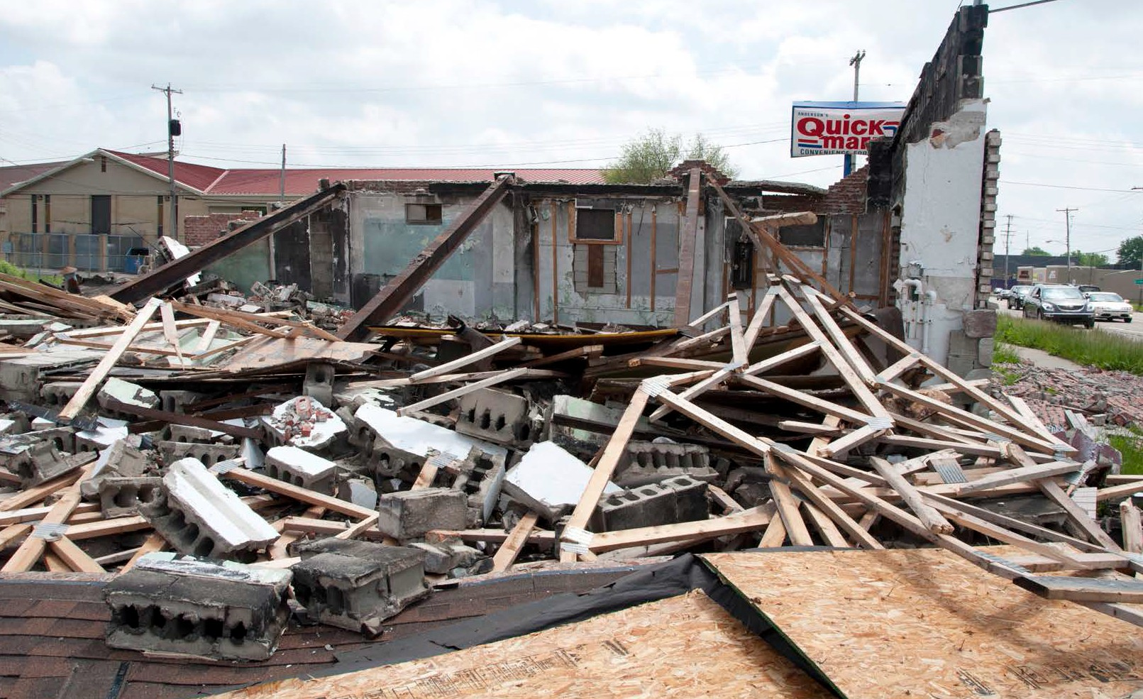
Destruction from a May 2013 Tornado in Genesee County

TORNADO AND THUNDERSTORM SAFETY

How far do tornadoes travel once they touch the ground?
The average Michigan tornado is on the ground for less than 10 minutes and travels about five miles. However, they do not always follow the norm and have been known to stay on the ground for more than an hour and travel more than 100 miles.

When is a tornado or severe thunderstorm watch issued?
A tornado or severe thunderstorm watch is issued whenever conditions exist for severe weather to develop. Watches are usually for large areas about two-thirds the size of Lower Michigan and are usually two-to-six hours long. Watches give you time to plan and prepare.

When is a tornado or severe thunderstorm warning issued?
The local National Weather Service (NWS) office issues a tornado warning whenever NWS Doppler Radar indicates a thunderstorm can produce a tornado, or when a tornado has been sighted by a credible source. A severe thunderstorm warning is issued whenever a severe thunderstorm is observed, or NWS Doppler Radar indicates a thunderstorm can produce damaging winds or large hail.

Warnings are issued specifically for areas expected to be impacted by a severe storm. These “storm-based” NWS warnings are issued for the threatened area in a shape of a polygon.

The “polygon” warnings only include sections of a county or group of counties and usually last for 30 to 90 minutes in length. You must act immediately when you first hear the warning. If severe weather is near you, seek shelter immediately. If not, keep a constant lookout for severe weather and stay near a shelter.

What is a special marine warning?
The NWS will issue a special marine warning for the Great Lakes and the connecting waterways when a strong or severe thunderstorm develops or moves over the water. The special marine warning is issued for boaters, both recreational and commercial. For residents and visitors of Michigan’s many coastal communities, the special marine warning provides valuable information about a storm that is about to move onshore.

How do I find out about a warning if my electricity is already out?
A NOAA Weather Radio All-Hazards with battery back-up capability is your best source to receive the warning. In some areas, civil emergency sirens may be your first official warning, but it is important to remember that those sirens were designed to warn people outdoors about an approaching tornado or high-end severe thunderstorm…you may not hear your local siren inside your home. In addition, if your television or radio has battery back-up capability, you may receive NOAA’s National Weather Service warnings from local media, the internet or a smartphone app.

FLOOD PREPARATION AND PLANNING

STEPS TO PREPARE FOR A FLOOD

Flooding can occur during any season in Michigan. Planning in advance can afford you extra critical time when a flood is coming and can help you increase the odds of protecting your valuable documents, your real estate and your individual property – including cherished belongings. Developing a flood plan is one of the advance methods your family, business or community can put together to help you respond quickly in the event of a flood near your property. A “rapid-response” plan can be as simple as a one-page plan that answers the following questions:

- How will we find out about a coming flood?
The first part of a Flood Plan is putting yourself in a position to get some warning of an unfolding situation. Large-scale flooding on the main stem of a river may occur over many hours or several days, but flash floods can strike in minutes. Important steps you can take include signing up for flood alerts and monitoring weather patterns and local conditions.

Flooding in Michigan can happen any time of year.
  - Sign up for NOAA National Weather Service Flood Alerts at www.focusonfloods.org/flood-alerts
  - Monitor river levels from NOAA National Weather Service at www.water.weather.gov/ahps/region.php?state=mi.
  - Determine your property’s proximity to waterways by learning about and reviewing flood hazard maps at www.floodsmart.gov/floodsmart/pages/flooding_flood_risks/understanding_flood_maps.jsp.

- At what river level does our property begin to flood?
First, determine “What’s Your Number?” by learning the flood stage at the stream gage nearest you. This information is available through the National Weather Service’s Advanced Hydrologic Prediction Services website at www.water.weather.gov/ahps. Then, determine the level at which floodwaters begin to affect your property. This step may take research or personal experience to determine, such as talking to neighbors to find out how high the river was during recent floods, and at what point flooding began in your neighborhood. Each neighborhood and each property have its own unique terrain and placement to consider when determining this factor, and it is safest to err on the side of caution.

- How can we prepare for floods?
Preparing your household for a flood involves steps that will improve your readiness for several types of disasters. Give yourself plenty of time to evacuate by developing an emergency kit including first aid supplies, a three-day supply of non-perishable food, bottled water, a battery-powered radio, flashlights and extra batteries. Also, have personal items ready like rubber boots, a rain jacket, warm clothes, and hygiene and sanitation products. Learn additional ways to prepare at www.ready.gov/floods.

- How will we learn about evacuation orders?
Contact your local emergency management office to find out how your community notifies residents of floods and how it will issue evacuation orders. Make a commitment to follow evacuation orders the first time to help prevent emergency personnel from having to return to the affected area for a rescue when travel is no longer safe.

FLOOD INSURANCE
FLOOD PREPARATION AND PLANNING

FLOOD INSURAN
FLOOD INSURANC
- What access roads can we use to evacuate in the case of rising waters?
Research indicates much of flood-related fatalities occur when cars become trapped on roads that are known to flood. To prevent this, follow instructions from emergency personnel and before a flood happens talk to neighbors, emergency personnel and others to determine when and where flooding typically occurs on access roads leading to your home. Know what roads you regularly travel and whether they will flood and plan alternate routes when needed.

- What steps should we take to prepare our property?
Research the flood-proofing options available to you. Can you install a quick-disconnect furnace, or elevate electrical and mechanical equipment? Are there steps you can take to alleviate pressure on your structure and to prevent extensive damage to doors and windows if flooding does occur? For additional information about protecting your property from floods, please visit www.mcswa.com.

- Where should our family meet if we are separated during a flood event?
Before a flood or other emergency strikes, designate a safe place away from your home where your family members can all meet. Make sure that all family members know the location, you have a plan for contacting each other, and you have an emergency kit ready to take with you. In addition, it is important to know whether your child’s school or family members’ work place is in a flood zone. If so, what provisions are in place to ensure their safety?

- How do I keep my family safe during a flood?
Floods are among the most frequent and costly natural disasters. For information on keeping your family safe before, during, and after a flood, please visit: www.mcswa.com.
Other Considerations
  - A written plan is essential for helping individuals and household members to think through critical issues in advance. You should also research whether there are similar plans in place for your place of work and your children’s daycare and school and see how they work with your plan.
  - Expect roadways to be blocked during a flood. Contact your friends and family to ensure they are safely sheltered. Listen to local media for flooding on roads as well as contacting neighbors in your area.
  - Remember, some of the most common things people regret not planning to protect during an emergency include pets, photographs and computers. Can you pack all these in a vehicle and drive to higher ground in time? Ensure you have a plan in place to protect your pets and keepsakes before an emergency.
Helpful Flood Terms
  - Flood Watch: Flooding is possible. Tune in to your NOAA Weather Radio, local radio or television for information and check the flood alert sites on the Internet.
  - Flash Flood Watch: Flash flooding is possible. Be prepared to move to higher ground and tune in to your NOAA Weather Radio, commercial radio or television for information.
  - Flood Warning: Flooding is occurring or will occur soon. If advised to evacuate, do so immediately.
  - Flash Flood Warning: A flash flood is occurring. Seek higher ground immediately.

FLOOD INSURANCE
Why Buy Flood Insurance?

Flooding can occur during any season in Michigan. The National Flood Insurance Program (NFIP) estimates that 90 percent of natural disasters involve flooding. A small amount of water can bring a tremendous amount of damage, and many property owners are unaware that their properties are at risk for flooding. A home located in the floodplain has a four times greater risk for flood damage than fire damage during a 30-year mortgage.
Many property owners don’t realize that their homeowners’ or property owners’ insurance doesn’t cover flood damage. To be covered from flood damage, one must purchase National Flood Insurance through an insurance agent. Consider that even just an inch of water can require a property to replace carpet, drywall, floor boards, moldings, doors and other belongings. Additionally, clean-up of mud and residue can be costly, as can repairing any mold and mildew damage that may occur.
To help calculate flood damage that could occur to your home, visit www.floodsmart.gov and click on the link to learn more about “What Could Flooding Cost Me?”

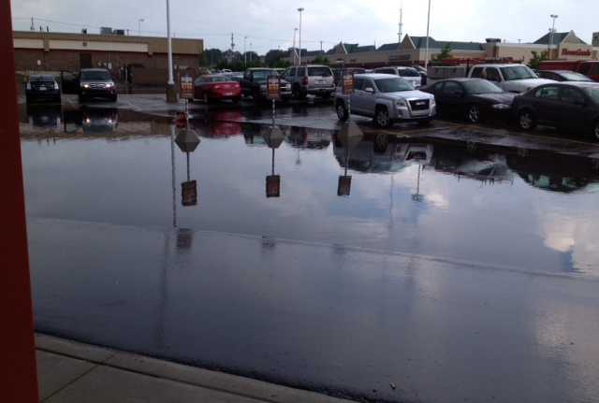

Flooding, Lansing, 2018

Is flood damage covered by my homeowner’s insurance?
Flood damage is excluded in nearly all homeowners and renter’s insurance policies can be purchased as a separate policy.

Where do I get flood insurance?
Any licensed property/casualty insurance agent can sell a flood insurance policy. If you experience trouble in locating an agent, contact the National Flood Insurance Program’s agent referral program at 1-888-CALL-FLOOD. You can also locate an agent by filling out your “One-Step Flood Risk Profile” at www.floodsmart.gov.

FLOOD INSURANCE
FLOOD PREPARATION AND PLANNING

Is there a waiting period before my flood insurance policy becomes effective?
There is a 30-day waiting period before a new or modified flood insurance policy becomes effective. You can also locate an agent by completing your “One-step risk profile” at www.floodsmart.gov

Do I need to live in a floodplain to get flood insurance?
It is important to note that nearly 30 percent of all flood claims come from outside the “100-year-floodplain” as determined by the National Flood Insurance Program (NFIP). The fact that a property is outside of the “legal” floodplain does not mean that the river or stream cannot still reach that property. You do not need to live in a floodplain to purchase flood insurance. Coverage is available to any building located in a community that has qualified for the National Flood Insurance Program. For a listing of Michigan communities participating in the NFIP, you may visit www.fema.gov/cis/MI.html%20.

Is water backup in basements covered by a flood insurance policy?
Coverage for water backup in basements (drains/ Can I get coverage for water back up in basements/sewers) is excluded from the flood insurance policy.

Although basement water back up is excluded under most homeowners’ insurance policies, coverage can be obtained by purchasing an endorsement. Most insurance companies offer sewer and drain backup as optional coverage. Coverage and limits vary by insurance company, so check with your agent/company about specifics. Some insurers include full coverage for sump pump failure while others specify items that are covered.

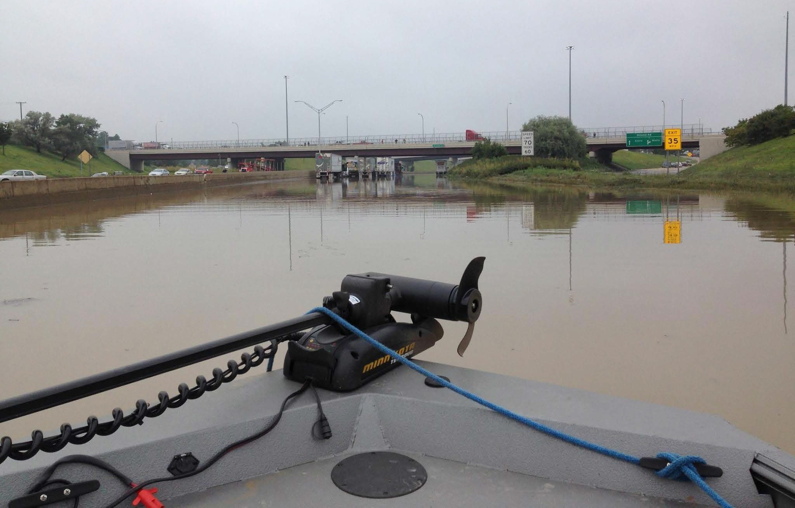
Highway Flooding, Detroit, April 2015

LIGHTNING SAFETY
Lightning can provide a spectacular display of light in the nighttime sky, but this awesome show of nature can also cause destruction and/or death. Lightning is the visible discharge of electrical energy. It is often accompanied by thunder, which is a sonic boom created by the same discharge. It is important to remember that if you hear thunder, a storm is close enough for lightning to strike you, even if the storm seems miles away and the sky is blue.

SAFETY TIPS

  - Plan your evacuation and safety measures. At the first sign of lightning or thunder, activate your emergency plan. Lightning often precedes rain, so do not wait for the rain to begin before suspending activities. No place is safe from lightning; however, some places are much safer than others. The safest location during lightning activity is a large enclosed building. The second safest location is an enclosed metal topped vehicle, but NOT a convertible, bike, or other topless or soft-top vehicle.
  - If outdoors, get inside a suitable shelter IMMEDIATELY. Your only safe choice is to get to a protected building or vehicle. Avoid seeking shelter under a tree as a tree can attract lightning. In the event you are outdoors without a safe vehicle or shelter, follow outdoor
safety tips provided at www.lightningsafety.noaa.gov/outdoors.shtml. Although these tips will not prevent you from being hit, they can help lessen the odds.
  - If indoors, avoid water, doors, windows, and using the telephone and headsets. Lightning could strike exterior wires, inducing shocks to inside equipment. Any item plugged into an electrical outlet may cause a hazard.
  - Do not resume activities until 30 minutes following the last observed lightning or thunder.
  - Injured persons do not carry an electrical charge and can be handled safely. If you are qualified to do so, apply first aid procedures to a lightning victim. Call 9-1-1 or send for help immediately.

For additional information, visit NOAA’s lightning safety Web site: www.lightningsafety.noaa.gov

DISASTER PREPAREDNESS FOR PETS
The following information, prepared by the Humane Society of the United States, will help you become better prepared to care for your pets in a disaster or emergency.

Don’t Forget Identification
    - Your pets should be wearing up-to-date identification always.
    - Put your cell phone number on your pet’s tag. It may also be a good idea to include the phone number of a friend or relative outside your immediate area—in case you must evacuate.

Find a Safe Place Ahead of Time
    - Don’t wait until a disaster strikes to do your research.
    - Evacuation shelters do not generally accept pets, except for service animals. Plan to ensure your family and pets will have a safe place to stay.
    - If you have more than one pet, you may have to prepare to board them separately. Make a list of boarding facilities and veterinary offices that might be able to shelter animals, including 24-hour telephone numbers.
    - Ask your local animal shelter if it provides foster care or shelter for pets during an emergency. Animal shelters have limited resources so this should be your last resort.
    - Contact hotels and motels outside of your immediate area to check policies on accepting pets. Ask about any restrictions on number of animals, size, and species, as well as whether a “no pet” policy would be waived during an emergency.
    - Make a list of pet-friendly places and keep it handy. Call ahead for a reservation as soon as you think you might have to leave your home.
    - Check with friends, relatives or others outside of your immediate area. Ask if they would be able to shelter you and/or your animals, if necessary.

If You Evacuate, Take Your Pets
    - The single most important thing you can do to protect your pets if you evacuate is to take them with you. If it is not safe for you to stay in the disaster area, then it is not safe for your pets.
    - Animals left behind in a disaster can easily be injured, lost or killed.
    - Animals left inside your home can escape through storm-damaged areas, such as broken windows.
    - Animals turned loose to fend for themselves are likely to become victims of exposure, starvation, predators, contaminated food or water or other accidents.
    - Do not leave your animals tied or chained outside during a disaster; this can be deadly.
    - If you leave, even if only for a few hours, take your animals. You have no way of knowing if you will be allowed back into the area to care for your pet.
    - Leave early; don’t wait for a mandatory evacuation order. An unnecessary trip is better than waiting too long, making it unsafe to leave.
    - Take pet food, medications, and special items with you such as leashes, toys, or a litter box.

In Case You Are Not Home
    - An evacuation order may be issued, or a disaster may strike, when you’re at work or out of the house. Decide well in advance for a trusted neighbor to take your pets and meet you at a specified location.
    - If you arrange for someone to take your pets, be sure the person is comfortable with your pets, knows where your animals are likely to be, knows where your disaster supplies are kept, and has a way to access your home.
    - If you use a pet sitting service, discuss the possibility of getting their assistance well in advance.

WEATHER WARNING SYSTEMS
NOAA Weather Radio All-Hazards
Voice of NOAA’s National Weather Service

NOAA Weather Radio All-Hazards is a service provided by the National Weather Service (NWS). It provides continuous broadcasts of the latest weather information and forecasts from your local NWS office. NOAA Weather Radio All-Hazards broadcasts important forecast and warning information as quick as possible.

With NOAA Weather Radio All-Hazards, you will always have access to potentially life-saving emergency information. During severe weather, NWS personnel can interrupt routine weather broadcasts and insert warning messages concerning immediate threats to life and property. A special alert tone can also be activated that triggers an alerting feature on specifically equipped receivers. In the simplest case, this signal activates audible or visual alarms indicating that an emergency condition exists within the broadcast area of the station. In the most sophisticated alerting system, receivers equipped with Specific Area Message Encoding (SAME) technology allow listeners to choose which counties and for what events their radio will sound an alarm when official NWS watches and warnings are issued.

NOAA Weather Radio All-Hazards broadcasts warning and post-event information for all types of emergencies, both natural and technological. Working with other federal and local agencies, NOAA Weather Radio is an “all-hazards” radio network. This makes NOAA Weather Radio All Hazards the sole source for the most comprehensive weather and emergency information available to the public.

NOAA Weather Radio All Hazards is the voice of the NWS and is provided as a public service by the U.S. Department of Commerce’s National Oceanic and Atmospheric Administration (NOAA). These life-saving receivers, that should be as common as home smoke detectors, can be purchased at many retail stores and through web sites that sell electronic merchandise. It provides the timeliest forecast and warning information from your local NWS office. This information can save your life.

For more information, including where you can buy a NOAA Weather Radio, visit www.nws.noaa.gov/nwr.

Wireless Emergency Alerts (WEAs)
Automatic weather warnings on your smart phone: no matter where you are

Imagine being on vacation when a tornado warning is issued for your area. How would you find out? If you own a smart phone or any other cellular phone purchased after January 1, 2013, you no longer must worry. The Federal Emergency Management Agency, the Federal Communications Commission, the National Weather Service, and CITA-The Wireless Association have developed a cell phone emergency alert system that will automatically notify you through a text-like message about urgent weather warnings, emergency messages from the President of the United States, and amber alerts. If you have a WEA enabled phone, you don’t have to sign up or do anything, you already have it. If you are not sure if your phone supports this recent technology, then check with your cell phone carrier. In some cases, all you may need to do is update your device’s software.

Wireless Emergency Alerts are a point-to-multipoint system, which means alert messages will be sent to those within a targeted area, unlike text messages which are not location aware. For example, if a person with a WEA-capable device from Michigan happened to be in Minnesota when a flash flood threatens in that area, they would receive an “Imminent Threat Alert” on their device.

While these alerts will appear on a person’s mobile device like a text message, Wireless Emergency Alerts are not text messages. Instead, WEAs use a different kind of technology to ensure they are delivered immediately and are not subjected to potential congestion (or delays) on wireless networks.

You can see additional information on Wireless Emergency Alerts from the NWS at https://www.weather.gov/wrn/wea.

NATIONAL WEATHER SERVICE

MARQUETTE: MQT
NWS Office, NOAA 112 Airport Dr. South Negaunee, MI 49866
906-475-5782, Ext. 726
Contact: Matt Zika Matthew.Zika@noaa.gov http://www.weather.gov/mqt/

GAYLORD: APX
NWS Office, NOAA Gaylord, MI 49735-9454
989-731-3384 Ext. 726
Contact: Jim Keysor James.Keysor@noaa.gov http://www.weather.gov/apx/

GRAND RAPIDS: GRR
NWS Office, NOAA
4899 South Complex Dr. SE Grand Rapids, MI 49512-4034 616-949-0643, Ext. 726
Contact: Jim Maczko James.Maczko@noaa.gov http://www.weather.gov/grr/
DETROIT/PONTIAC: DTX
NWS Office, NOAA 9200 White Lake Rd.
White Lake, MI 48386-1126 248-625-3309, Ext. 726
Contact: Rich Pollman Richard.Pollman@noaa.gov http://www.weather.gov/dtx

NORTHERN INDIANA: IWX
NWS Office, NOAA 7506 East 850 N.
Syracuse, IN 46567
574-834-1104, Ext. 726
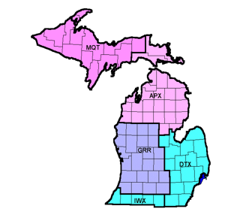
Contact: Michael Lewis Michael.Lewis@noaa.gov http://www.weather.gov/iwx/

